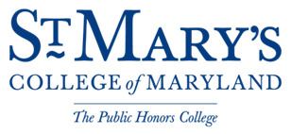

Capital Design Advisory Committee
Thursday, April 27, 2017

Cole Cinema, Campus Center
St. Mary’s College of Maryland
St. Mary’s City, Maryland
7:30 p.m.

AGENDA

- Wooden Pavilion Project - HSMC

- Current Visitors Center Rehabilitation - HSMC

- Dove Pier Replacement - HSMC
- Route 5 Traffic Calming Phase II Update - SMCM
- Trinity Church Road Sidewalk - SMCM
- New Academic Building/Auditorium and Jamie L. Roberts Stadium and Athletic Fields - SMCM

