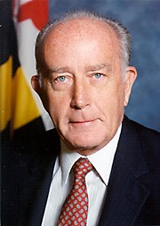

The Center for the Study of Democracy at St. Mary's College is proud to present the 2015
William Donald Schaefer Internship
Program for Government Service.

The competition is open to current St. Mary's College of Maryland students who hope to pursue a career in government service. The goal of the program is to allow undergraduates hands-on experience in public policy with the hope that they will be inspired to choose public service as a calling.

The award carries a stipend of $1,000 and assistance towards possible placement within a local, state or federal agency related to the winner's field of interest. Appropriate non- profit agencies will also be considered.

Qualifications: Current St. Mary's College
Sophomore or Junior; GPA must be at least
3.3; must be willing to work for at least six weeks during the summer 2015 and be able to work in local government or in government service associated with Annapolis, Baltimore or Washington, D.C.

Application Deadlines: A completed application package is due to Adrienne Dozier (amdozier@smcm.edu) in Kent Hall 103 by Monday, March 23. Oral interviews will follow as appropriate. The announcement of the final award will be made in late April.
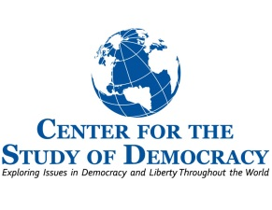
The William Donald Schaefer Internship Program for Government Service

The Center for the Study of Democracy at St. Mary's College of Maryland

Summer 2015

William Donald Schaefer served his community, state and nation with distinction for more than half a century.

Joining the U.S. Army during World War II, Schaefer was an officer in the U.S. Army administering hospitals in Europe. He entered politics in 1955 as a Baltimore City Councilman and became the Mayor of Baltimore in 1971. In 1986, after 15 years as Mayor, he was elected to the first of two terms as Governor of Maryland and later served as the state’s Comptroller from 1998-2007.

As Governor, William Donald Schaefer championed the designation of St. Mary's College of as Maryland's Public Honors College and advocated for the science building that is now named for him. In his role as trustee of the College, he continues to play a key role in leading St. Mary's into the 21st century. He is the recipient of 15 honorary degrees and the Jefferson Award for Public Service.

As a lasting tribute to the Governor's many contributions to the College and the state, The William Donald Schaefer Internship Program honors his lifetime commitment to achievement in government service.
____________________________________

This program is made possible through the generous support of Terry Meyerhoff Rubenstein, Henry A. Rosenberg Jr., and friends of William Donald Schaefer.

