Biology Style Manual
SMCM BSM

Department of Biology

St. Mary’s College of Maryland
St. Mary’s City, Maryland

2020

TABLE OF CONTENTS

Page

Purpose . . . . . . . . . . . . . . . . . . . . . . . . . . . . . . . . . . . . . . . . . . . . . . . . . . . . . . . . . . . . . . . . . . . . . 3

The Anatomy of a Formal Research Report . . . . . . . . . . . . . . . . . . . . . . . . . . . . . . . . . . . . . . . . . 3

Citing the Work of Others . . . . . . . . . . . . . . . . . . . . . . . . . . . . . . . . . . . . . . . . . . . . . . . . . . . . . . 6

Tables and Figures. . . . . . . . . . . . . . . . . . . . . . . . . . . . . . . . . . . . . . . . . . . . . . . . . . . . . . . . . . . . 9

Our Expectations . . . . . . . . . . . . . . . . . . . . . . . . . . . . . . . . . . . . . . . . . . . . . . . . . . . . . . . . . . . . . . 16

How to Judge Writing . . . . . . . . . . . . . . . . . . . . . . . . . . . . . . . . . . . . . . . . . . . . . . . . . . . . . . . . . . 17

Posters and Oral Presentations . . . . . . . . . . . . . . . . . . . . . . . . . . . . . . . . . . . . . . . . . . . . . . . . . . . 18

Purpose
The purpose of the Department of Biology Style Manual is to guide the writing and presentations required of biology students throughout their time at St. Mary’s College of Maryland. The Style Manual provides a standard format for writing and gives the specific requirements and expectations that department instructors will use to evaluate written work. We also offer some suggestions for oral presentations and posters.

Some initial guidance
Unpublished works are referred to as manuscripts. To format your manuscript, the SMCM Biology department follows the guidance of the Ecological Society of America (ESA). Please note that other journals have different formatting requirements. The ESA recommend the following manuscript formatting guidelines:
- Manuscript and literature cited should be double spaced, 12 point Times New Roman font.
- Follow the organization below. ESA formatting has been followed as closely as possible in the section below so you can see what it looks like. Other parts of this SMCM BSM have been single spaced to save space.
- All pages starting with the title page gets numbered.

The anatomy of a formal research report
Laboratory or technical reports serve several useful functions: (1) they provide a clear record of your laboratory work; (2) they evaluate raw experimental data and relate them to other information you possess; (3) they provide an avenue for you to learn the elements of scientific writing; and (4) they provide your instructor with a document demonstrating your progress in understanding biology. To this end, you should draft your laboratory reports as scientific communications, that is, as if you were going to send them to an editor for publication in a scientific journal.

Below is an outline of the form in which many scientists write their reports.

TITLE PAGE

Develop a carefully worded, concise title that describes the experiment. On the title page, also include your name, the names of your lab teammates, the date, and the course for which you wrote the report.

ABSTRACT

This section is a very brief overview of all of the main sections of the report, highlighting major results and conclusions. Authors often prefer to write this section last since it is a summary of the entire paper. The abstract helps readers decide if the paper is of interest to them. Abstracts are usually limited to 200-300 words and rarely include in-text citations. As a summary of work done, an abstract is always written in the past tense. As a general guideline, an abstract should include just 1 or 2 sentences describing each of the following:
1) An introduction to the broad problem the research addressed
2) The objective of the study and/or hypothesis(es) tested
3) Major methods used
4) Key results
5) Conclusions/broader implications of the study

INTRODUCTION

The purpose of the Introduction is to identify the current research on the topic, identify gaps in that research, and explain how your research will fill those gaps. This section gives background information, setting the stage for your research. Develop your ideas from the general to the specific, explaining what is known, then what’s not known, and why your contribution is valuable and interesting. A common error is to begin with a description of what you did; be sure you give background first! You will need to cite others’ research from journal articles, book chapters, etc., and when you refer to this work use the past tense. Refer to published literature as described in the "Literature Cited" section below. The introduction should culminate in the objective and/or hypothesis(es) tested by your study.

METHODS

The objective of the Methods section is to allow others to judge the validity of the experiment and even to repeat it for themselves. This section should briefly describe the methods you used for your experiments, including data analyses such as statistical methods. Be concise and thorough, but avoid unnecessary detail. When possible, refer to published methods you have adopted, noting any additions or changes you employed. Always write the Methods section out in text format (not in a cookbook, outline, or list format), but use sub-headings when appropriate. In this section you do not give the results you obtained, nor do you discuss them. Always use the past tense in the Methods section.

Here are some suggestions for writing a good Methods section:
- Arrange the information in a logical order, beginning with the experimental design, and ending with the statistical analyses. Note that a logical order need not be directly chronological; it’s more important that the overall method is easy to follow. Example sub-headings may include: Experimental design, Study Site, Study Organisms, Data Collection, Statistical Analyses,
- Use active voice for brevity and clarity: “We measured coleoptile length…” rather than “Coleoptile length was measured…..”
- Use tables and figures (photographs, drawings, or graphs) sparingly in this section to clarify and document your procedures. You must make reference to these in the Methods narrative, for example: “We built an apparatus (Figure 1) to hold the wombat during the experiments.”
- Include scientific names of organisms, complete names of apparatus (including model number, manufacturer, and place of manufacture), and chemicals, as well as any information that may be significant to your results. For example: “We determined photosynthetic rates using a LiCor 6400 portable gas exchange system (LiCor Inc., Lincoln, Nebraska, USA).”
- Remember to italicize scientific names. Do not capitalize common names unless they are proper nouns (“brine shrimp” or “blue crab,” but “Maine lobster”).
- Do not include results or discussion.
- Be concise and thorough, but avoid unnecessary detail such as the size of the beakers you used (unless for some reason this information is crucial to repeating the experiment). Also avoid details about common laboratory procedures, such as how you standardized a pH meter or spectrophotometer.

RESULTS

The Results section should include:
1) A narrative with an objective description of results, without interpretation. This includes a summary of numerical results, including descriptive statistics (e.g. means, standard errors) as well as the results of statistical tests (including P values). Include parenthetical references to figures and/or tables here.
For example: “Respiration rate increased with temperature in all species (Figure 1), but there were significant differences among species (ANOVA: P < 0.001).”

2) Figures and/or tables interspersed within the text. Every table and figure must be described in the Results section, in the order that they are referred to in the text of your paper. Do not present the same data more than once. Choose the best way to present the data, as a table or as a figure, but not both.
For example: “The activity of the enzyme showed a sharp optimum at 37o C (Figure 1), and the reaction rate plateaued after 10 minutes (Figure 2).”

DISCUSSION

The purpose of this section is to:
- Remind the reader of the hypothesis and discuss whether the data supported or refuted the predictions.
- Place your work in context of previously published work (using in-text citations), to help explain why you got the results you did.

Questions to help guide your discussion:
- Provide reasonable suggestions as to why you got the results you did. If your results do not support your hypothesis, suggest biological reasons why.
- Do your data support (or refute) previously published work?
- What future experiments might you suggest and why?

Usually the last part of the Discussion section is a summary of conclusions, a discussion of significance of the work and/or suggestions for future research.

ACKNOWLEDGMENTS

You have undoubtedly received significant help from faculty, reviewers, and maybe funding. Include thanks for help you have received here.

LITERATURE CITED

Each reference requires both an in-text (interior) citation and full reference using the “hanging indent” in the Literature Cited section. In the text, refer to literature by placing the author(s) and the year of the publication in parentheses. For example, a statement in the introduction might read as follows: “The enzyme sequence is found in bacteria from hot springs and is likely to be active at high temperatures (Byrd and Colwell 1992).” The Literature Cited section gives details that allow a reader to find the original document:

Byrd, J.J., and R.R. Colwell. 1992. Detection and enumeration of bacteria in the environment by microscopic methods. Pages 34-56 in M.A. Levin, R.J. Seidler, and M. Rogul, editors. Microbial ecology: principles, methods, and applications. McGraw-Hill Publishing Company, New York, New York, USA.

The (Byrd and Colwell 1992) example above demonstrates the use of in-text citations and Literature Cited entries, but you’ll need more information to format different types of citations correctly. The Department of Biology citation format is detailed below. Remember: interior citations and full references ALWAYS appear in pairs.

Citing the work of others

Whenever you take information (intellectual property) from another person, you must give credit and enable the reader to check your information source as well as learn more about the cited studies. The Department of Biology has chosen the format used by the Ecological Society of America as our standard format. If questions arise about citation style or other technical issues, you should consult the instructions to authors for this journal (http://esapubs.org/esapubs/preparation.htm), or look at the journal Ecology itself for examples. Please consider these general rules:
- Cite only those sources you actually read and used in the development of your paper.
- Avoid referring to unpublished materials (school papers, lecture notes, etc.)
- Citing reviews or texts is sometimes appropriate for general information, but, when possible, cite primary literature.
- You must have at least one in-text citation for every entry in your Literature Cited section, and every in-text citation must have a corresponding reference in Literature Cited.

Avoiding plagiarism
Plagiarism is the act of appropriating and using the words or ideas of other works without giving credit. This includes word-for-word copying AND close paraphrasing.
- You do not need to cite an idea that is standard biological information. For example: “Cells are either prokaryotic or eukaryotic” or “Charles Darwin and Alfred Russel Wallace formulated the theory of evolution by natural selection.”
- Quotations are rare in scientific writing; avoid using them.
- Remember, even when you write in your own words, you must include a reference to give credit for the source of the idea or information.

Citation of references in the text
In general, in-text citations belong at the end of the sentence in which the research was mentioned, in chronological order.
For example: “Many types of animals can see ultraviolet radiation (Smith 1996, Thomas and Jones 2000, Paul et al. 2003).”

Occasionally, you may wish to place an in-text citations within a sentence just after a material from a specific source is mentioned.
For example: “Birds (Smith 1996), bees (Thomas and Jones 2000) and butterflies (Paul et al. 2003) all see ultraviolet radiation.”

You may also want to cite the author more directly.
For example: “Smith (1996) showed that birds can see ultraviolet radiation.”

In-text citations should follow the (name year) system:
One author: (Smith 1998)
Same author(s) of two or more papers in a year: (Smith 1998a)
Same author(s) multiple years: (Smith 1998a, 1998b, 1999, 2002)
Two authors: (Smith and Jones 1998)
Three or more authors: (Smith et al. 1998)
Multiple citations, same year- alphabetic: (Smith 1998, Taylor 1998)
Multiple citations, different years- chronological: (Taylor 1978, Smith 1998)
Manuals: (Department of Biology 2016, American Public Health Association 2017)
Government Publication: (United States Environmental Protection Agency 2007)
Web Site: (Watson and Dallwitz 1992, St. Mary’s College of Maryland 1998)
Unpublished data: (J.J. Price, Personal Communication, date)
Use personal communication only when necessary. This type of citation is one of the few cases where there is no reference to the citation in the Literature Cited section of the paper.

Citation of references in the literature cited section
The citations in the Literature Cited section should be in alphabetical order by the last name of the first author of the reference. Note that the Literature Cited section is single spaced with an extra space between citations, and that ALL the authors must be listed. If the same first author has been cited more than once, then the order of the publications is by the last name of the second author. Examples of different reference types follow.

Note that we have separated references by type (journals, books,…) so you can understand the different examples, but in your Literature Cited section, you should list all your references together regardless of type.

Traditional journal articles – accessed either in hardcopy or online:
Arnold, T. M., C. E. Tanner, and W. I. Hatch. 1995. Phenotypic variation in polyphenolic content of the tropical brown alga Lobophora variegata as a function of nitrogen availability. Marine and Ecological Progress Series 123: 177-183.

Cramer, E. R. A., and J. J. Price. 2007. Red-winged blackbirds respond differently to song types with different performance levels. Journal of Avian Biology 38: 122-127.

Paul, R. W., W. I. Hatch, W. P. Jordan, and M. J. Stein. 1989. Behavior and respiration of the salt marsh periwinkle, Littorina irrorata (Say), during winter. Marine Behaviour and Physiology 15: 229-241.

Wadeson, P. H., and K. Crawford. 2003. Formation of the blastoderm and yolk syncytial layer in early squid development. Biological Bulletin 203: 216-217.

Online journal articles – available only online:
Kerry, S., M. TeKippe, N. C. Gaddis, and A. Aballay. 2006. GATA transcription factor required for immunity to bacterial and fungal pathogens, PLoS ONE, e77. doi:10.1371/journal.pone.0000077.

Books (Whole):
Byrd, J. J., and T. Powledge. 2006. Complete idiot's guide to microbiology. Alpha Press, Indianapolis, Indiana, USA.

Book (Chapters):
Myerowitz, R. 2001. The search for the genetic lesion in Ashkenazi Jews with classic Tay-Sachs disease Pages 137-143 in R. J. Desnick and M. M. Kaback , editors. Tay-Sachs disease. Academic Press, New York, New York, USA.

Power, M. E., W. E. Rainey, M. S. Parker, J. L. Sabo, A. Smyth, S. Khandwala, J. C. Finlay, F. C. McNeely, K. Marsee, and C. Anderson. 2004. River-to-watershed subsidies in an old-growth conifer forest. Pages 217–240 in G. A. Polis, M. E. Power, and G. A. Huxel, editors. Food webs at the landscape level. University of Chicago Press, Chicago, Illinois, USA.

Lab manuals or appendices:
Department of Biology. 2019. Enzymology: polyphenol oxidase. Pages 49-58 in Laboratory manual for principles of biology I. St. Mary's College of Maryland, St. Mary's City, Maryland, USA.

St. Mary's Projects/Theses/Dissertations:
Phung, A. 2006. Nutrition and skeletal disease in the seventeenth century colonial Chesapeake. St. Mary's Project, St. Mary's College of Maryland, St. Mary's City, Maryland, USA.

Government publications:
United States Environmental Protection Agency. 2007. Hazardous waste management system: identification and listing of hazardous waste; amendment to hazardous waste code F019, Proposed rule. Federal Register 72: 2219-2235.

United States Department of Energy. 2006. Breaking the biological barriers of cellulosic ethanol: a joint research agenda, DOE/SC-0095. U.S. Department of Energy Office of Science and Office of Energy Efficiency and Renewable Energy, Washington, D.C., USA.

Websites:
International Union for Conservation of Nature and Natural Resources. 2018. The IUCN red list of threatened species. Version 2018.1. <http://www.iucnredlist.org>. Downloaded on 22 June 2019.

Tables and figures

Tables and figures present results more clearly and concisely than can be done in text. Every table and figure must have a number and must be referenced in the text. Tables and figures should be numbered sequentially and displayed in numerical order (i.e., you should not discuss Fig. 2 before discussing Fig. 1). Tables are numbered separately from figures, but graphs and other illustrations (photographs, drawings, etc.) are numbered together and collectively referred to as "figures."

Tables
Tables usually present specific data that are critical to understanding a scientific paper. A table has two components: 1) the table number with its caption (sometimes called a caption title) and 2) the table itself. The table caption is always placed above the table and should not extend past the margins of the table itself. The table is bounded by horizontal lines showing where the table begins and ends. The first row in the table contains the column headings and this row is separated from data by another horizontal line. Generally vertical lines are only used to separate columns of data that are grouped. Therefore, do not use lines to identify or separate individual columns. Below is an acceptable example of a table (Table 1).

Table 1. Characteristics of antibiotic-producing Streptomyces spp.
Organism | Optimal growth temp (°C) | Color of mycelium | Antibiotic produced | Yield of antibiotic (mg/mL)
S. fluoricolor | -10 | Tan | Fluoricillinmycin | 4
S. griseus | 24 | Gray | Streptomycin | 108
S. coelicolor | 28 | Red | Rholmondelaya | 78
S. nocolor | 92 | Purple | Nomycin | 2

Other table formatting details
Scientific journals encourage abbreviations in tables to save space, but be sure to define those abbreviations in the table caption. Be sure to include units (if applicable) in the column headings. In the table caption, also include the sample size (n=100) used to calculate the mean and the standard error of the mean (SE). Table 2 below provides an example.

Table 2. Mean length (± SE) of pine (loblolly, Pinus taeda, and Virginia red pine, Pinus viginiana) needles (n=100) collected at different locations on the St. Mary’s College of Maryland campus.
Stand ID | Location | Needle length (mm)  Pinus taeda Pinus virginiana
QA | Queen Anne Hall - west of parking lot | 26.7 ± 7.8 | 14.6 ± 2.0
NF | North Field – behind barns | 28.6 ± 6.5 | 13.6 ± 1.5
LQ | Northwest of Lewis quadrangle | 26.5 ± 3.9 | 16.0 ± 2.2
PGC | Behind Prince George’s and Caroline dormitories | 27.7 ± 6.8 | 12.9 ± 1.8

Figures
Figures include graphs, photographs, drawings, and anything else that is not a table. Figures are numbered and discussed sequentially and parenthetically in the body of the Results section.

Choice of figure type
In general, graphical figures show the dependence of data (called the dependent variable) on some treatment or condition (called the independent variable). The dependent variable is plotted on the y-axis while the independent or grouping variable (often controlled by the researcher) is plotted on the x-axis. Variables that fall along a numerical scale are called numerical variables (e.g. height of trees in a forest, or percent increase in insect damage), and variables that instead fall into discrete categories are called categorical variables (e.g. eye color, tree species). It is essential that you know what types of variables you are working with before you make a figure! Below we discuss examples of several different basic figure types you may make as a biology student, but of course there are many others which you may need to use in your research. The figures below were generated using Microsoft Excel, but there are other useful programs for producing figures. In the following section we provide these same figures generated in R, as well as the R Code used to generate them.

Figure captions
Figure captions should largely stand alone, and the reader should be able to understand what a figure is showing without reading the results section. Captions are placed below the figure, and represent a concise description of the data being displayed, including the following components:
- Labels for both axes, including units if applicable
- Number of replicates in each group (n) if applicable
- Any abbreviations used
- What error bars represent (e.g. ± SE)
- If a statement is made that is supported by statistical analysis, include the test and P value here in addition to in the text of the Results section (e.g. t-test: P < 0.001)
- If more than one dataset is presented, provide legend details (e.g. gray circles = elevated temperature treatment, black circles = control)

Note the captions in the example figures below to help guide you, and of course check out figure captions in your favorite journals for additional inspiration.

A) Bar graphs
Use a bar graph when you want to show a categorical independent variable and a numerical dependent variable. (Note that this is called a “column graph” in Excel). A bar graph displays the mean values of the dependent variable as heights of different bars, and the categories of the independent variable along the x axis. Never display a mean value on a figure without also presenting error bars of some type. Below is an example of a bar graph with error bars that represent ± 1 standard error (SE). Notice that the figure number and caption are located below and at the left margin of the figure and that the figure caption does not extend beyond the right margin of the figure.

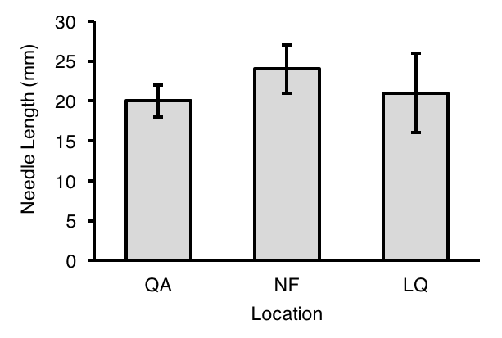
Figure 1. Mean length (± SE) of pine needles (n=100) collected at different locations on the St. Mary’s College of Maryland campus. QA= Queen Anne Hall, NF=North Field, LQ=Lewis quadrangle.

B) Scatter plots
A simple scatter plot is used when both your independent and dependent variables are numerical. It shows if two variables are associated or correlated with each other, or not. If, using statistical analyses, you find a significant relationship between the variables, you may add a trend line to your plot (shown below). Use this type instead of connecting the points when the relationship between the two variables is more informative than actually connecting points.

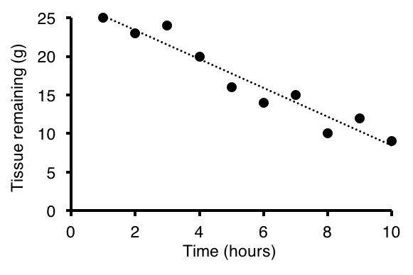
Figure 2. The relationship between epidermal tissue remaining and time in the arthropod decomposition experiment. The dashed line represents the linear regression between these two variables (P < 0.01; R²=0.92).

C) Scatter plots with connected points
A scatter plot with connected points is a good way to represent a dataset that demonstrates a directional trajectory of some kind where connections between points are biologically meaningful. Use this figure type when you may wish to extrapolate values between points, but where you don’t necessarily want to fit a trend line to them (as above).

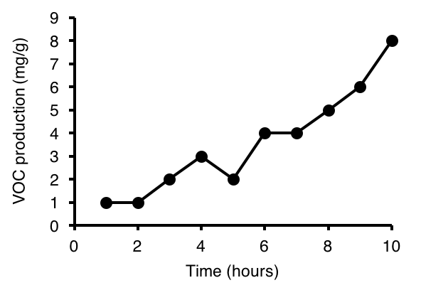
Figure 3. Volatile organic compound (VOC) production, measured as mg emitted per gram of tissue, measured over the course of 10 hours in plants exposed to water stress (n=23).

Making figures using R
The program R can also be used for making figures. Below are some examples, followed by the codes used in making them. These figures show the same data that are shown in the Excel figures above. Many programs are available to generate figures, each with different costs and benefits. How you make your figures is up to you, just as long as they follow the general guidelines described earlier.

A) Bar plot
A bar plot (also called bar graph or column graph) is useful when you have a categorical independent variable and a numerical dependent variable. It displays the mean values of the dependent variable as heights of different bars, and the categories of the independent variable along the x axis. Never display a mean value on a figure without also presenting error bars of some type. Below is an example of a bar plot with error bars that represent ± 1 standard error (SE).

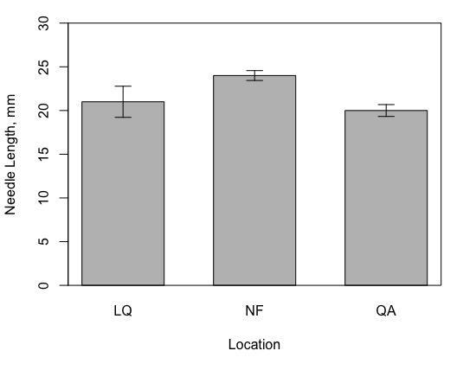
Figure 1. Mean length (± SE) of pine needles (n=10) collected at different locations on the St. Mary’s College of Maryland campus. LQ-Lewis quadrangle, NF-North Field, QA-Queen Anne Hall.

B) Box plot
Box plots are not easily generated using Excel. A box plot displays the dependent variable as boxes and whiskers, and the categories of the independent variable along the x axis. The solid line in the center of each box represents the median value of each group, the top and bottom edges of each box represent the first and third quartiles, respectively, and the edges of the whiskers represent the maximum and minimum values in the dataset. The example below shows the same data that are presented in Fig. 1; ultimately it’s up to you to decide which type of figure shows the data best.

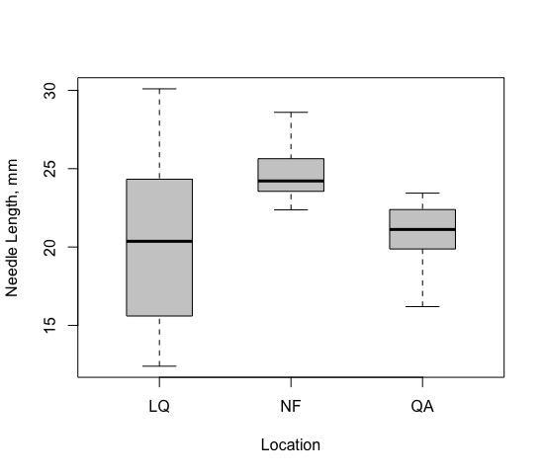
Figure 2. Box plots of length of pine needles (n=10) collected at different locations on the St. Mary’s College of Maryland campus. LQ-Lewis quadrangle, NF-North Field, QA-Queen Anne Hall.

C) Simple scatter plot
A scatter plot is used when both your independent and dependent variables are numerical. It is used to show if two variables are associated or correlated with each other, or not. If, using statistical analyses, you find a significant correlation between the variables, you may add a trend-line to your plot (shown below). Use this type instead of connecting the points when the relationship between the two variables is more informative than actually connecting points.

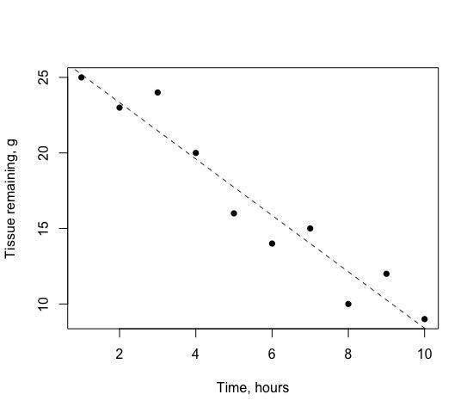
Figure 3. The relationship between epidermal tissue remaining and time in the arthropod decomposition experiment. Dashed line represents the linear regression between these two variables (P < 0.01; R²=0.92).

D) Scatter plot with connected points
A scatter plot with connected points is a good way to represent a dataset that demonstrates a directional trajectory of some kind where connections between points are biologically meaningful. Use this figure type when you may wish to extrapolate values between points, but where you don’t necessarily want to fit a trendline to them (as above).

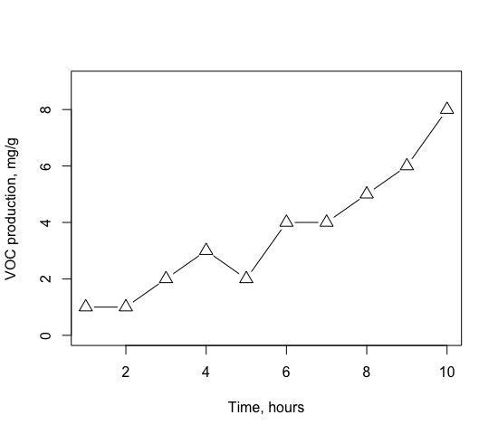
Figure 4. Volatile organic compound (VOC) production, expressed as g emitted per g tissue, measured over the course of 10 hours in plants exposed to water stress (n=23).
R code used to make these figures

# R code for style manual example figs

# data for box and bar plots
# note, because the 3 following lines generate unique sets of numbers each time,
# your figures will look slightly different from the ones in the manual
QA <- rnorm(10, mean=20, sd=2)
NF <- rnorm(10, mean=24, sd=3)
LQ <- rnorm(10, mean=21, sd=5)
Location <- c(rep("QA",10),rep("NF",10),rep("LQ",10))
Needle_Length <- c(QA,NF,LQ)
Needles <- data.frame(Location,Needle_Length)
# boxplot
boxplot(Needles$Needle_Length~Needles$Location,boxwex=0.5,
col="gray80", ylab="Needle Length, mm", xlab="Location")
# bar plot
Means <- c(21,24,20)
SES <- c(sd(LQ)/sqrt(10),sd(NF)/sqrt(10),sd(QA)/sqrt(10))
barx <- barplot(Means, ylim=c(0,30), ylab= "Needle Length, mm",
xlab="Location", names.arg = c("LQ","NF","QA"),
space=0.6)
arrows(barx, Means+SES, barx, Means-SES, angle=90, code=3, length=0.1)
box()

# simple scatter plot with trendline
xvals <- 1:10
yvals1 <- c(25,23,24,20,16,14,15,10,12,9)
plot(yvals1~xvals, pch=16, xlab="Time, hours", ylab="Tissue remaining, g")
abline(lm(yvals1~xvals), lty="dashed", col="gray20")

# scatter plot with connecting lines
yvals2 <- c(1,1,2,3,2,4,4,5,6,8)
plot(xvals, yvals2, pch=2, cex=1.5, type="b", ylim=c(0,9),
xlab="Time, hours", ylab="VOC production, mg/g")

Our expectations
We expect good writing. It is your responsibility to turn in grammatically correct and clearly written assignments. Due dates must be respected. It is our responsibility to help you learn by pointing out problems, but we are not proofreaders.

General suggestions
- Edit and proofread thoroughly. Using a spelling checker is simply not enough. Read your work aloud and see if it makes sense. Allow enough time to revise your draft documents.
- The best way to become familiar with the style of scientific papers is to read them. Go to the library and find some journal articles that describe experimental results; use them as a guide in your own writing.
- Refer to a writing handbook if you have questions about grammar. There are many excellent writing guides. You may already have such a handbook, but if not you should consider buying one. We suggest buying the following (it is available in the Campus Store):
- McMillan, V.E. 2016. Writing papers in the biological sciences, 6th edition. Bedford/St. Martin’s, Boston, Massachusetts, USA.
- Get help! Use the writing Center!. You will often be working in teams, so you'll have built-in proofreaders—take advantage of this and swap papers for comments!

Specific suggestions
These are suggestions we have compiled because they address problems we see commonly:
- Word usage, choice of the appropriate word to convey precise meaning, is most important and can be learned by reading widely. Write grammatically correct, straightforward English sentences that contain a subject, object and verb. Think about what each sentence actually says, not what you think it says. Ask yourself if it is possible to misinterpret the sentence.
- Follow a consistent pattern of tense. Record observations and experiments in the past tense; use the present tense for generalizations and references to stable conditions. Use past tense for your unpublished results and for the published experimental results to which you refer.
- Avoid direct quotations except when the specific words used by the original author are particularly important, for example, "It has not escaped our notice that the specific pairing we have postulated immediately suggests a possible copying mechanism for the genetic material." (Watson, J. D., and F. H. C. Crick. 1953. A structure for deoxyribose nucleic acid. Nature 171: 737). Do not use them just because you cannot easily think of how to say something in your own words.
- The word "data" is plural (“datum” is singular): "My data show…," NOT "My data shows." This is a very common error! Other common singular/plural errors are spectrum/spectra and bacterium/bacteria.
- Use the passive voice sparingly; it requires extra words and may not convey the exact meaning. Compare "Fungi produce antibiotics" with "Antibiotics are produced by fungi." The passive here requires two more words and 25% more space. "It was found to have had" is simply, in the active voice, "It had." If you use "I" or "we" ("we" for two or more writers, never as a substitute for "I"), you easily avoid the passive voice, at least in that one sentence. Instead of "It was reported by Smith," just describe what Smith reported and put the name and date in parenthesis at the end (Smith 1983). Be alert for "by" as the danger sign of the passive voice.
How to judge writing
The SMCM Writing Center prepared the following guidelines several years ago. They do not always apply directly to scientific writing, but they are excellent points to keep in mind.

1. Higher order concerns (HOCs)
These concerns are pervasive. They involve the essence and purpose of the piece, and as a rule they cannot be found at particular points on the page. Crucially, they must be improved by revision (i.e., re-seeing), not editing. Fixing problems in grammar, usage, and so on will have no beneficial effect on HOCs. The HOCs are as follows; the questions that accompany them can help a writer determine the extent to which these concerns have been satisfied.
- Focus: Is the piece about one main idea? Does it stay with this idea or wander off? Is the idea about the right size for the length of the piece, or is it too general to allow a detailed discussion? Is the focus relevant, useful to the intended readers?
- Development: Does the piece present enough information so that the reader feels that the work is complete? Are there specific details that develop or support generalizations? Are uninformative summaries, mere assertions, and other vague subjectivity avoided?
- Structure/Organization: Does the piece have a logical structure? Are ideas presented in an order that makes sense, considering the purpose of the paper? Are paragraphs about one main idea? Is the reader introduced to the topic at the beginning and led to an ending that creates a sense of completeness or conclusion? Are sections of the piece linked together by transitions?
- Audience: For whom is this piece written? What sort of action or reaction does the writer expect from the audience? How much does the audience know, and what are/might they be interested in? What views or prejudices do they already hold, and has the writer reckoned with these? Do the other HOCs reflect what the writer knows about the audience and his/her purpose?

2. Lower order concerns (LOCs)
These are not called lower order because they are unimportant. In fact, getting these concerns wrong will often cause the writer as much trouble as neglecting HOCs. LOCs have their name for three reasons:
- Writers must worry about them after they have gotten the HOCs into reasonable shape. Making significant editing changes before whole sections of the text are added, moved, or deleted during revision only wastes time, since the HOCs will have to be attended to anyway, and the writer will have to edit again for LOCs.
- In general, LOCs have to do with the linguistic surface of a piece of writing, not with its content or purpose, which are much more complicated matters.
- LOCs are fixed by editing and by referring to rules, a much simpler business for writers than discovering what they are saying and how to say it. Writers should always deal with HOCs first.

Examples of LOCs include:

spelling
punctuation
subject-verb
agreement
verb tense
fragments
run-ons
comma
splices
sentence structure
parallel structure
misplaced modifiers
dangling modifiers
manuscript form
pronoun agreement
pronoun reference
word choice

Posters and oral presentations

Posters
Posters are appropriate when you want to discuss your work with a few people at a time. such as semester-end poster sessions, St. Mary's Projects poster sessions and scientific conferences. Posters stimulate conversation and provide a more flexible format than research reports. See “How to Make a Great Poster” on the Biology SMP website.

Basic format of a poster:

- Abstract or Summary
- Introduction - brief
- Methods - brief and visual such as a timeline or flowchart
- Results - large figures centrally located
- Conclusion - brief
- Literature Cited - smaller font
- Acknowledgments - smaller font

Oral presentations
Oral presentations are appropriate when you want to present your work to a group, such as your class, St. Mary’s Project presentation, or a scientific conference. This is a visual representation of your work, avoid text heavy slides.

Organization
- Introduction - include current research, gaps in that research, and how your research will fill the gaps. The introduction slides culminate with your hypothesis.
- Methods - visual timeline or flowchart
- Results - large figures, typically one per slide
- Conclusion - revisit hypothesis, was it supported?
- Future Directions - next logical steps
- Acknowledgments – people and funding sources who supported the research but are not coauthors
- Questions - optional slide that indicates to the audience that your presentation is over
- Do not include a Literature Cited slide

Slide tips
- Keep slides simple, with no fancy fonts or clutter
- Use a large clear font, text should be minimal
- Figures should be large with axis titles legible, usually one figure per slide
- Plan for approximately 1 slide per minute

Answering questions
- Anticipate questions you may be asked and how you will answer them
- Direct your answer to the person asking the question, keep your response short
- For a group presentation, take turns fielding questions
- If you don't know the answer to a question, admit it, and then try an educated guess

General advice
- Practice several times to assess timing and to reduce reliance on notes
- For group presentations, divide speaking evenly among group members, rotating to a new member for each slide, not by section
- Do not read off of the screen, face your audience and make eye contact.

