Deadline: February 15th, 2019

CALL FOR ENTRIES

THE McCUTCHEON FAMILY ART AWARD

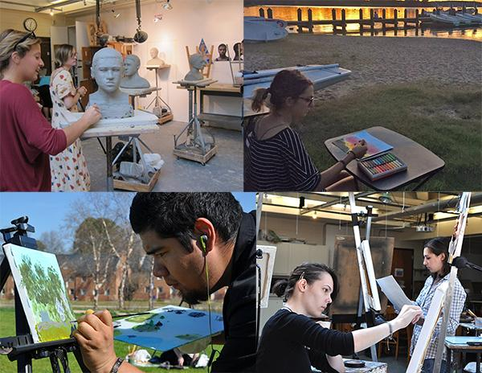

The McCutcheon Family Art Award is a $400 award established in 1991 by Janet McCutcheon in memory of her husband, Frank (class of 1989) and given to a Junior or Senior art major or minor who demonstrates artistic promise. The winner is selected by the Art faculty and announced at the College's annual honors convocation.

Eligibility: Open to declared Art Majors and Minors with junior or senior standing (56 credits or more.)

Process: Complete the attached application form that requires images of six artworks in any medium and email to Stephanie Scott at sascott@smcm.edu by February 15, 2018.

DIGITAL APPLICATION FORM BELOW
(also available from any art faculty upon request)

The McCutcheon Family Art Award, 2019

The McCutcheon Family Art Award is a $400 award established in 1991 by Janet McCutcheon in memory of her husband, Frank (class of 1989) and given to a Junior or Senior art major or minor who demonstrates artistic promise. The winner is selected by the Art faculty and announced at the College's annual honors convocation.
Eligibility: Open to declared Art Majors and Minors with junior or senior standing (56 credits or more.)
2019 Deadline: February 15

Submission Instructions
- Complete this form exactly as instructed below and save it, renaming it yourlastname_2019_mccutcheon.docx
- Attach this file to an email and send it to the AAH department Assistant Stephanie Scott at sascott@smcm.edu

Complete the following:
Student Name:

1. Work Statement (Optional): Write a brief statement or any explanation you would like to provide to contextualize your work.

2. Portfolio: Provide images and information of six of your best artworks in any media. Videos must be no longer than 2 minutes and uploaded to a hosting site (vimeo, youtube) and the link pasted in one of the table cells (i.e. instead of an artwork image).

a. Image List: Provide the following info for each artwork submitted: title, medium, size, year

- Artwork #1:
- Artwork #2:
- Artwork #3:
- Artwork #4:
- Artwork #5:
- Artwork #6:

b. 6 Images: Paste one image per artwork into the corresponding table cell and resize so that each table cell occupies no more than one page (MS word>Insert>Pictures> Pictures from file)

Artwork #1:

Artwork #2:

Artwork #3

Artwork #4:

Artwork #5:

Artwork #6:

